F:\SPORTWMN\WSPRT023.WMFF:\SPORTWMN\WSPRT024.WMF



F:\SPORTWMN\WSPRT009.WMFF:\SPORTWMN\WSPRT028.WMF

Cycling

Golf

Ice skating

Fencing

F:\SPORTWMN\WSPRT064.WMFF:\SPORTWMN\WSPRT062.WMF



F:\SPORTWMN\WSPRT070.WMFF:\SPORTWMN\WSPRT066.WMF

Hurdles

Horse riding

Relay

Weight lifting

F:\SPORTWMN\WSPRT081.WMFF:\SPORTWMN\WSPRT078.WMFF:\SPORTWMN\WSPRT074.WMFF:\SPORTWMN\WSPRT071.WMF

Ice skating

Skiing

Skateboarding

Sailing



F:\SPORTWMN\WSPRT030.WMFF:\SPORTWMN\WSPRT041.WMF



F:\SPORTWMN\WSPRT035.WMFF:\SPORTWMN\WSPRT036.WMF

Hoops

Ribbons

Target practice

Diving

F:\SPORTWMN\WSPRT059.WMFF:\SPORTWMN\WSPRT055.WMF



F:\SPORTWMN\WSPRT060.WMFF:\SPORTWMN\WSPRT061.WMF

Table tennis

Parachuting

Canoeing

Climbing

F:\SPORTWMN\WSPRT047.WMFF:\SPORTWMN\WSPRT046.WMFF:\SPORTWMN\WSPRT040.WMFF:\SPORTWMN\WSPRT037.WMF

Skiing

Tennis

Judo



Handball

F:\SPORTWMN\WSPRT083.WMFF:\SPORTWMN\WSPRT082.WMF



F:\SPORTWMN\WSPRT097.WMFF:\SPORTWMN\WSPRT096.WMF

Water polo

Volleyball

Javelin throw

Football

F:\SPORTWMN\WSPRT020.WMFF:\SPORTWMN\WSPRT016.WMF



F:\SPORTS02\SPORTS15\S15197.WMFF:\SPORTWMN\WSPRT029.WMF

Hockey

Hang gliding

Discus throw

Bowling

F:\SPORTWMN\WSPRT002.WMFF:\SPORTWMN\WSPRT004.WMF



F:\SPORTWMN\WSPRT005.WMFF:\SPORTWMN\WSPRT006.WMF

Baseball

Basketball

Badminton

Karate

F:\SPORTS12\S12194.wmfF:\SPORTS02\SPORTS15\S15198.WMF



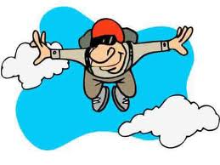F:\SPORTS02\SPORTS10\S10137.WMF

Sky diving

Windsurf

Motocross

Archery

S13025S13031S13043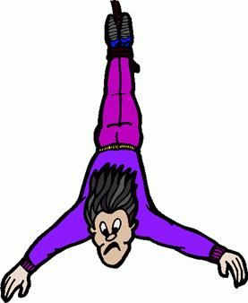

Swimming



Surf

Boxing

Bungee jumping