Erasmus+ Pictures for Video Game App

# | Image | Correct answer | False 1 | False 2 | False 3
1 | 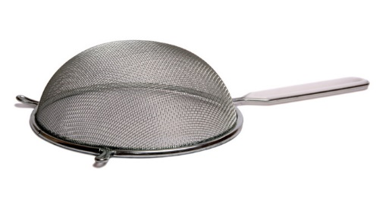 | sieve | peeler | colander | grater
2 | 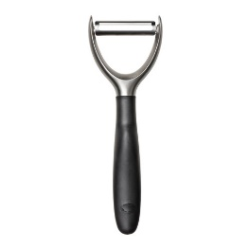 | peeler | grater | whisk | ladle
3 | 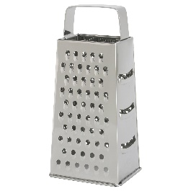 | grater | peeler | mortar and pestle | masher
4 | 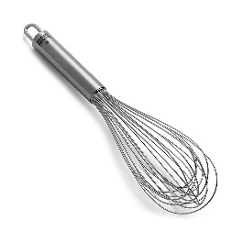 | whisk | ladle | hob | sieve
5 | 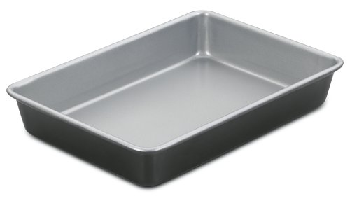 | baking pan | tray | drainer | colander
6 | 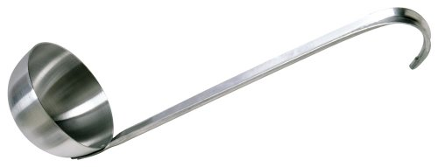 | ladle | pie slice | masher | soup spoon
7 | 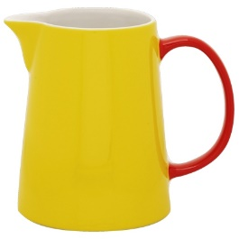 | jug | pot | drainer | colander
8 | 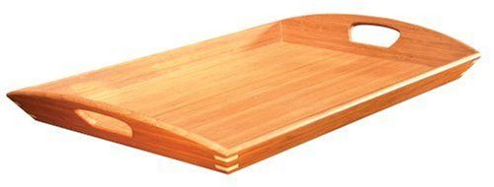 | tray | drainer | baking pan | platter
9 | 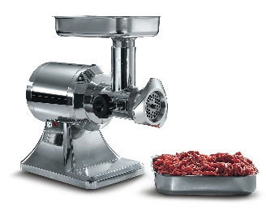 | mincer | masher | whisk | mortar and pestle
10 | 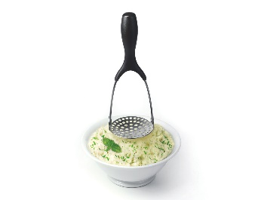 | masher | mincer | grater | scales
11 | 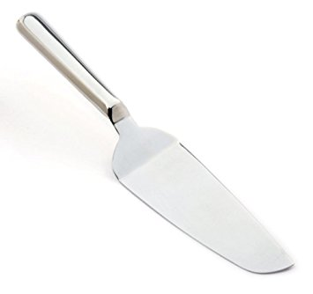 | pie slice | ladle | peeler | steel
12 | 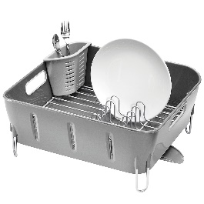 | drainer | baking pan | tray | hob
13 | 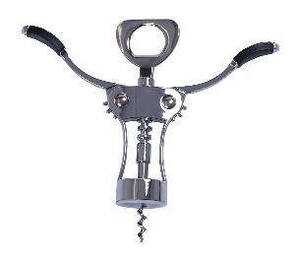 | corkscrew | mortar and pestle | tin opener | rolling pin
14 | 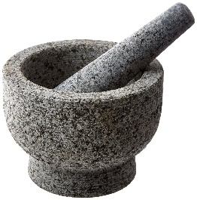 | mortar and pestle | masher | rolling pin | jug
15 | 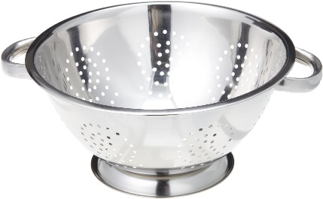 | colander | sieve | baking pan | saucepan
16 | 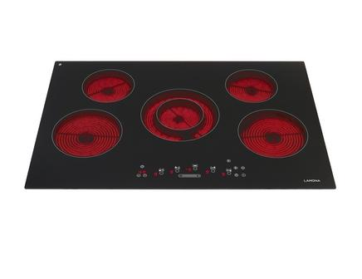 | hob | oven | stove | work top
17 | 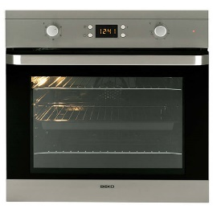 | oven | hob | stove | cooker
18 | 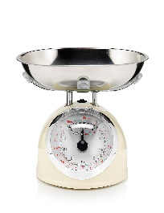 | scales | mortar and pestle | steel | corkscrew
19 | 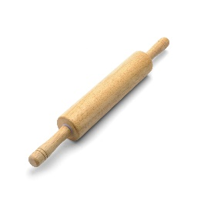 | rolling pin | steel | pie slice | sieve
20 | 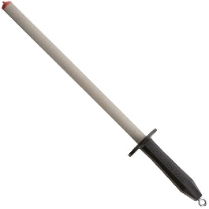 | steel | corkscrew | mincer | ladle
21 |  | Boxing | Fighting | Wrestling | Kicking
22 | 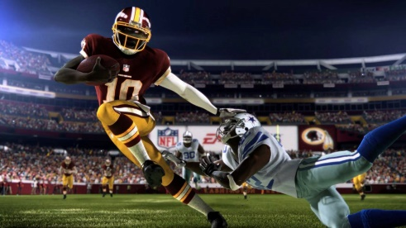 | American Football | Soccer | Football | Basketball
23 | 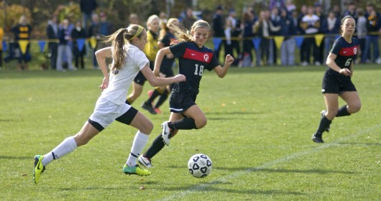 | Football | Ball kicking | Handball | Basketball
24 | 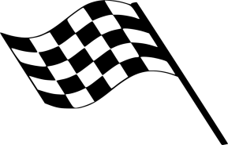 | Chequered Flag | Square Flag | Rounded Flag | White and black flag
25 |  | Volley shot | Free kick | Snapshot | Penalty kick
26 | 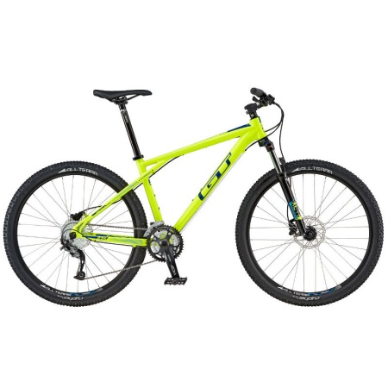 | Mountain bike | Touring bicycle | Flat bike | Motorbike
27 | 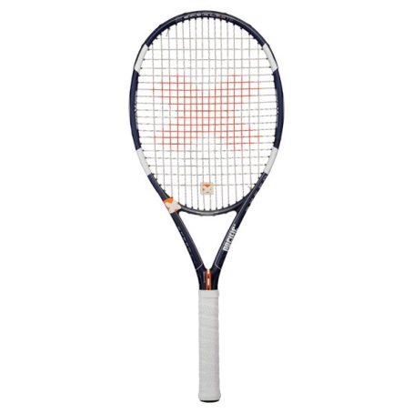 | Racquet | Rocket | Raquet | Racket
28 |  | Hockey | Hoquey | Jockey | Hoky
29 | 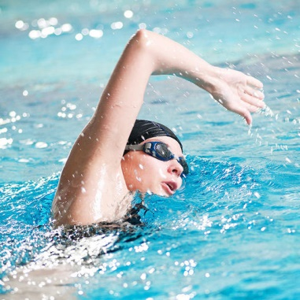 | Swimming | Smiling | Snorkelling | Scuba diving
30 |  | Scuba diving | Swimming | Snorkelling | Breathing

